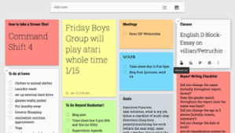1) Google Keep
Google Keep as his way to record homework assignments, I was immediately hooked. Google Keep is one of my top executive function apps to develop time management, planning, and prioritizing skills. It is linked to your google account and is accessible on your computer, smartphone, and tablet. Other helpful features include color coding notes for different categories and setting reminders to complete a task. No more excuses that your child ignored or lost her to do list!

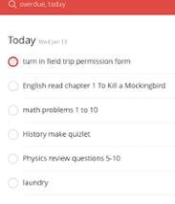2) ToDoist
ToDoist. (You read that correctly, it’s ToDoist, not another To Do List). used ToDoist to create folders for each class, as well as add, reorder and break down assignments that I knew other students would have success with this tool. Recently, I introduced this tool to one student as a way to help him record his daily assignments and prioritize work..

3) Habit List Habit List is a tool to help build positive habits and track trends over time.

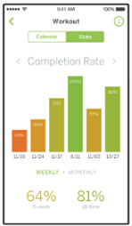. The reminders to complete a habit really helps build accountability. I’ve never been more motivated and successful crossing going to the gym off my list!

Organization App - YouNote!

YouNote! is a unique and creative take on traditional note-taking apps. This app allows users to take notes using a variety of different methods, ensuring that learners of all different types can stay organized. Users who benefit from learning visually can take advantage of YouNote!’s ability to take notes using hand-drawn images. For those who learn better from auditory cues, this app also allows users to take voice-recorded notes. Notes can be tagged and sorted for easy access later. This app can be extremely helpful for keeping track of important information from school, home, or the workplace. Discover more in our YouNote! review.

Organization App - Google Calendar
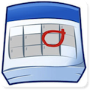
Google Calendar is software available from nearly any computer or mobile device that allows a single user or group of users to create and maintain a digital calendar of events. Keeping track of upcoming assignments, obligations, or important appointments through Google Calendar can help users keep a hectic and busy life organized. The program can be synced across multiple devices or shared with a group to ensure that everyone in the family, class, or workplace can stay organized and on the same page. Find out more in our Google Calendar review.

