Working Memory
Working Memory App - Quizlet
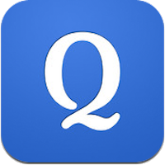

Whether it’s for memorizing literary terms or historical figures, flashcards are one of the most helpful learning tools. Quizlet is an app and a website that allows children to create their own digital flashcards so they can learn their terms and definitions. They app is great for studying on the go, while the online version is better for inputting the information. The app even offers mini-games to make the process more engaging. Flashcards can be organized by class and subject, making Quizlet one of the best apps for working memory. See our Quizlet review for all the information.

