Time Management
Time Management App - InClass
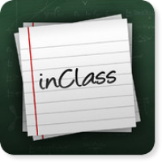
For a more academic approach to time management, consider downloading InClass. This scheduling app is geared towards middle-school, high-school, and college-aged students and lets users add class times, professors, homework, and due dates to their calendar. It is also a handy study tool, as it lets users attach recorded content, files, and notes to each reminder, For older kids starting to manage large school work loads, InClass offers an excellent way to help them stay on top of assignments. Check out ourInClass review for all the details.

